Manual Instructions of 3rdChina (Shenzhen) Innovation & Entrepreneurship International Competition

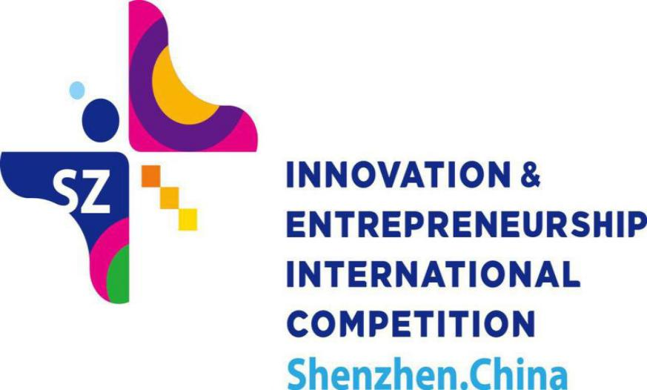

Contents

Introduction 3
Events 4
Applications & Requirements 6
Procedures 7
Awards and Supporting Policies 9
Cooperative Investment Institutions & Finance Institutions 13
Notes 14
Introduction to Shenzhen, China 15
Introduction to Bao’an District, Shenzhen 17
Introduction to Longgang District, Shenzhen 19
Introduction to Pingshan District, Shenzhen 22

Introduction
China (Shenzhen) Innovation & Entrepreneurship International Competition (hereinafter referred to as the “International Competition”) aims to integrate innovation and entrepreneurship resources and help foreign innovation and entrepreneurship projects to connect with Chinese hi-tech industrial resources and expand the Chinese market for mutual benefits and win-win results.
This competition is open to all foreign innovation and entrepreneurship projects with no restrictions on competitors’ nationality. Bonus of this competition totally reaches RMB 11.2 million, which includes individual bonus up to RMB1.4 million (Government subsidies and venture capital investments are not included). A venture capital pool of RMB 25 billion has been set up by 40 investment institutions, which helps support outstanding projects. Equal opportunities of social investment are going to be distributed via the platform to all participants which are going to be invited to the Conference on International Exchange of Professionals in Shenzhen as well.
Additionally, policies for entrepreneurship incentives, industrial incentives, technology and financial policies and project incubation are going to be provided in this competition.

Events

Overseas Division Competitions: March, 2019

Sydney Competition, Australia Division
Toronto Competition, Canada Division
Berlin Competition, Germany Division
Tel Aviv Competition, Israel Division
Tokyo Competition, Japan Division
Madrid Competition, Spain Division
Stockholm Competition, Sweden Division
Boston Competition, U.S.A Division
Silicon Valley Competition, U.S.A Division
London Competition, U.K. Division

Professional Competitions: March, 2019（Preliminary）
April 9th, 2019（Finals）

Internet of Things
Artificial Intelligence
Financial Technology

Industrial Finals: April 10th, 2019

Internet and Mobile Internet (information technology)
Electronic Science and Technology
Biology and Life Science and Technology
Advanced Manufacturing
Materials &Energy (including energy conservation and environmental protection)
Finals: April 12th, 2019

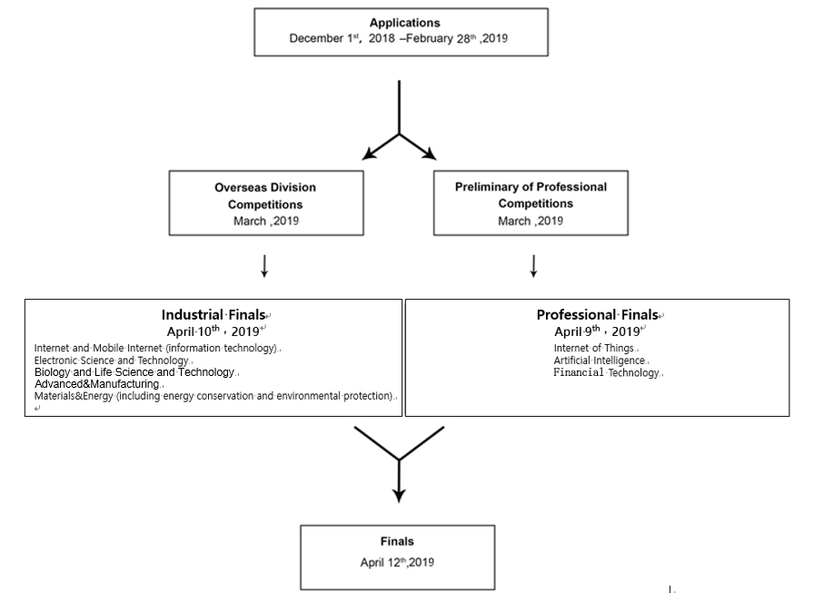

Applications & Requirements

(Ⅰ) Applications & Requirements
The Participants (Teams or individuals) should:
1. be those who have innovation achievements and business plans；
2. have plans of entrepreneurship in Shenzhen within 6 months after the competition;
3. should possess full ownership of all rights related to the product, the technology and the patent, have no property dispute with any other person, and assume full responsibility caused by any possible infringement;
4. those who had won prizes in previous competitions held overseas by Shenzhen or domestic or international awards of previous China (Shenzhen) Innovation and Entrepreneurship Competitions shall not compete in this Competition.

(Ⅱ) Industrial Fields
Projects should correspond to Shenzhen Industrial and Technical policies, superior innovation abilities, advantageous marketing competitiveness and potential economic and social performance, which will not only be able to possess core technique, complete intellectual properties and high added-value products but also bring High-tech products of new industries into being.
Five categories are involved in Industrial Competitions: Internet and Mobile Internet (information technology), Electronic Science and Technology, Biology and Life Science and Technology, Advanced Manufacturing, and Materials & Energy (including energy conservation and environmental protection). As for key industries of Shenzhen, Internet of Things (IOT), Artificial Intelligence (AI), and Financial Technologyare set in the Professional Competitions.

(Ⅲ) Entry Requirements
1. In case of any change in registration information during the Competition, participants shall make a written request for changeset the Secretariat of the Organizing Committee. Updated information shall not be used in subsequent competitions and applications for relevant preferential policies until duly recorded and updated by the Secretariat of the Organizing Committee.
2. Any participant who quits during the course of the Competition will be deemed to give up all rights and interests of the Competition.

Procedures
The procedures of the competitions are: Applications, Overseas Division Competitions, Professional Competitions, Industrial Finals, and Finals.

(Ⅰ) Applications
1.Application method: Visit the official website of the Competition (www.itcsz.cn) to register and apply.
2. Deadline: February 28th, 2019
Notes: The deadline of application and the time of competitions are subject to the final confirmation on the official website.
You will directly gain access to Preliminary of Professional Competitions if your projects correspond to the given options of the Professional Competitions.

(Ⅱ) Overseas Division Competitions
1.Time：March, 2019
2.Divisions：Sydney(Australia), Toronto(Canada) , Berlin(Germany) ,Tel Aviv(Israel), Tokyo(Japan), Madrid (Spain), Stockholm(Sweden), Boston(U.S.A), Silicon(U.S.A), London(U.K.)
3.Overseas Division Competitions are divided into2 rounds.
In the first round, experts are going to be organized to review projects. Top 4 Candidates of each division are going to be selected out from every industry in accordance with scores to enter the Overseas Division Finals.
In the second round, experts of each division are organized to review projects for the Overseas Division Finals. Candidates are going to compete live by means of roadshow. Winners of the first, second, and third prizes are going to be ranked in accordance with scores. Top 2 candidates of each industry are going to be qualified into the Industrial Finals in Shenzhen.
During the Overseas Division Competitions, experts shall be invited to perform entrepreneurship coaching and training for candidates selected to compete in the Industrial Finals.

(Ⅲ) Professional Competitions
1.Time：March, 2019(Preliminary)
April 9th, 2019(Finals)
2.Categories: Internet of Things, Artificial Intelligence, Financial Technology
3.Professional Competitions are divided into2 rounds.
In the first round, famous experts of professional fields are going to be organized by organizations of every professional competition to review projects. Top 15 participants of each profession are going to enter the Professional Finals in accordance with scores.
The second round is the Professional Finals. Candidates are going to compete respectively by means of roadshow. Winners of the first, second, and third prizes are going to be ranked in accordance with scores given by professional experts. Top 3 candidates of every professional finals are going to be qualified into the Finals.

(Ⅳ) Industrial Finals
1.Time: April 10th, 2019
2.Categories: Internet and Mobile Internet (information technology), Electronic Science and Technology, Biology and Life Science and Technology, Advanced Manufacturing, Materials & Energy (including energy conservation and environmental protection)
3.Distinguished candidates of 5 industries in the Industrial Finals are going to compete respectively by means of roadshow. Winners of the first, second and third prizes are going to be ranked by professional experts. Top 3 candidates are going to be qualified into the Finals.

(Ⅴ) Finals
1.Time: April 12th,2019
2.On the day of the Finals, the First, Second and Third final prizes will be selected by professional and public judges through site roadshows and Q&A sessions.
During the Competition, a field visit to local innovation and startup environments will be arranged for contestantsto promote cooperation with local enterprises and institutions, startup parks, investors, and businesses in relevant industries to assist in their development of the Chinese market. Travel subsidies will be provided by the Organizing Committee to the finalists who come to Shenzhen for the Finals (2 persons for every project at most).

(Ⅵ) Review
The Competition is going to follow the principles of ‘fairness, justice and openness’. Experts of technological, human resources, and investment fields are going to organized to ensure justice and equity of the whole competition.

Awards and Supporting Policies

(Ⅰ) Cash Prizes

No. | Category | Prize | Quantity | Prize
1 | Finals | First | 1 | RMB 1,000,000
2 | Finals | Second | 3 | RMB 500,000
3 | Finals | Third | 6 | RMB 300,000
4 | Industrial Finals | First | 1 | RMB 150,000
5 | Industrial Finals | Second | 2 | RMB 100,000
6 | Industrial Finals | Third | 3 | RMB 50,000
7 | Professional Finals | First | 1 | RMB 150,000
8 | Professional Finals | Second | 2 | RMB 100,000
9 | Professional Finals | Third | 3 | RMB 50,000
10 | Overseas Division Competitions | First | 1 | RMB 100,000
11 | Overseas Division Competitions | Second | 2 | RMB 50,000
12 | Overseas Division Competitions | Third | 3 | RMB 30,000

(II) Industrial Incentive Policies

No. | Supporting Organization | Contents | Remarks
1 | Science & Technology Innovation Committee of Shenzhen Municipality | Winning projects in overseas division competitions that are eligible for local industrial supporting policies and are based in Shenzhen will be awarded up to RMB 1 million as start-up funds by regulations. | 1. Projects shall conform to local industrial supporting policies;  2. Projects shall be settled down in Shenzhen;  3. For winning projects in overseas division competition;  4. Priority will be given by regulations.

(III)Science & Technology Finance Policies

No. | Supporting Organization | Contents
1 | Cooperative Investment Institutions | A pool of RMB 25 billion has been set up by 34 investment institutions, which helps support outstanding projects. Moreover, professional management, consulting, business planning and other supporting services are provided.
2 | China Merchants Bank | 1.Helping instruct competitors to complete the registration of Shenzhen business affairs, and recommending cooperative lawyers who are able to provide legal services for competitors;  2.Provide financial services of settlement for competitors, including but not limited as below: personal settlement accounts, application of personal credit cards, personal social security cards, reserved fund cards and housing mortgage loans.
3 | Bank of Jiangsu | Enterprises with certificates of intellectual properties can debit and credit maximum amount of RMB 30 million.

(IV)Incubation and Other Policies
No. | Supporting Organization | Contents | Remarks
1 | Entrepreneurial Parks in Shenzhen | Winning projects in overseas division competitions that are settled down in Shenzhen will have priority to access the creative and industrial parks as well as incubators at the municipal and district level. Rent reduction/exemption, bonus and other benefits will be offered as well. | 1. Projects shall be based in Shenzhen；  2. Prize-winning projects in overseas division competitions.
2 |  | Information query, engagement meeting organization, centralized project demonstrations, closed-door meetings and other services will be provided to the Participants and engaged investors.
3 |  | Winning teams who plan to settle in Shenzhen will be provided with supporting services such as start-up trainings, management consultations, mentorship guidance, patent applications, and innovation resources. Chances to professional exhibitions, international communication, and talent recruitments will be provided as well. | 1. Projects shall be settled in Shenzhen；  2. Prize-winning projects in overseas division；  3. Priority will be given by regulations.
Please pay attention to the official website, official Wechat and official Weibo to know more information above. Policies and settlement of this competition are subject to official announcement.

Cooperative Investment Institutions & Finance Institutions
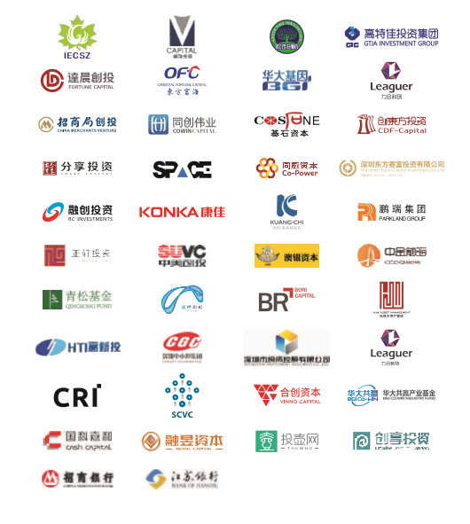

Notes
The Competition will be video-recorded and broadcast on TV media to promote candidates’ projects.
The Organizing Committee will organize related training activities for participants who are qualified to the second round. Schedules and venues will be published on the official website. Changes prior to the schedule will be announced in the Notification section of the official website.
The Organizing Committee of The Second China (Shenzhen) Innovation and Entrepreneurship International Competition reserves the copyright and the final interpretation rights of the Competition Manual. The Competition Manual is for reference only. In case of any changes, please refer to the official website of the Competition.

Official website of the Competition:
www.itcsz.cn
Official WeChat of the Competition’s Organizing Committee:
Shenzhen Innovation International Competition
Official Weibo of the Competition’s Organizing Committee:
Shenzhen Innovation International Competition
Secretariat of the Organizing Committee:
Address: 6/F, Shenzhen Talents Park, No. 8005, Shennan Avenue, Futian District, Shenzhen, China
Tel: (86) 0755-83671231 83556951 88128768

Introduction to Shenzhen, China
Shenzhen is a coastal city in South China. It is located on the eastern bank of the Pearl River, neighboring Hong Kong. Shenzhen has been a touchstone for Chinas reform and opening-up policy.
From 1979 to 2018, Shenzhen has skyrocketed from a tiny border town with a population of more than 30,000 to a metropolis with a population of more than 10 million. It has become a prosperous, chic, innovative, harmonious and beautiful city and established many firsts in the history of world industrialization, urbanization and modernization.
The Economist marveled at the "Miracle of Shenzhen," saying Chinas most extraordinary practice since its reform and opening up 40 years ago is the establishment of special economic zones and calling Shenzhen the biggest success of more than 4,000 SEZs in the world.
As one of the most important international cities in China, Shenzhen is one of the most economically dynamic cities in the world. The city is the high-tech and manufacturing hub of southern China as well as a State-level innovative city. It has set up new standards of Shenzhen Quality.
Shenzhen is the best example of Chinas historic leap from "getting on its feet" to "becoming prosperous." Its GDP has grown from 197 million yuan in 1979 to 2.24 trillion yuan in 2017, ranking only after Beijing and Shanghai, equaling Hong Kong and is among the top 30 cities in the world.
Shenzhen now has become an international metropolis with great influence and boasts the countrys best market-based, law-based and international business environment. It has the worlds third-largest container port, Asias largest land border port and Chinas five largest airports. Its home to seven Fortune Global 500 companies — Huawei, China Merchants Group, Ping An Group, Tencent, Vanke, Amer International Group and Evergrande. It has attracted more than 200 of Fortune 500 companies to invest here.
In Shenzhen, there are 5.6 State-level high-tech companies every square meter. An average of 51 patent applications are authorized daily and the citys investment in R&D accounts for over 4 percent of its total GDP.
Shenzhen offers best public cultural services, hosts cultural exhibitions and performances regularly and enjoys a beautiful environment. It has nearly 1,000 parks. The enviable "Shenzhen Blue Sky" and its developed volunteer culture have made Shenzhen a paradise for entrepreneurs and makers from all over the world. It has been called as "a city without winter" and won the title of "2017 Amazing China — The 10 Most

Introduction to Bao’an District, Shenzhen

Bao’an District is located in the northwest of Shenzhen and on the eastern coast of the Pearl River Estuary. It serves as an important node along the Guangzhou-Shenzhen-Hong Kong Golden Corridor. It has a land area of 397 square kilometers; it administers over 10 sub-districts currently, which are comprised of 124 communities with an actual population of 5.65million.a coast that stretches over 45 kilometers, occupying 17.3% of the entire city; and a sea area of 220 square kilometers, contributing to 10.9% of the entire city. The district is equipped with major traffic infrastructure, such as an international airport, DaChan Bay Harbor, China National Highway 107 and Bao’an Avenue. It has five expressways, including Guangzhou-Shenzhen Expressway, Ji He Expressway, Riverine Expressway, Nanshan-Guangming Expressway and Longhua-Dalingshan Expressway, as well as Metro Line 1, 5 and 11. Shenzhen Bao’an International Airport has implemented joint sea and land transportation with Hong Kong International Airport, while Metro 6, 12, 13 and 20, Guangzhou-Dongguan-Shenzhen Intercity Line, Hong Kong-Shenzhen Airport Speed Rail, Airport East Sky Train Comprehensive Hub and Shenzhen-Zhongshan Bridge are being planned and under construction. This leads to the preliminary formation of a comprehensive sea, land and air transportation network.

Bao’an is a major economic, industrial and export district in Shenzhen. It has a solid industrial foundation with clear export-oriented characteristics. It has formed an industrial structure that is steered by strategic emerging industries, led by electronic information industry and supported by equipment manufacturing and traditional advantage industries. In 2017, its GDP reached RMB344.8 billion, accounting for 15.4% of the entire city ,split equally between secondary and tertiary industries. The district has 2,779 enterprises above the designated size, ranking first in the city; as well as 3,030 national hi-tech enterprises, accounting for 27% of the entire city and ranking first in the city and among districts and counties in the province in terms of total quantity. As of today, the district has a total of 36 listed companies and 149 NEEQ-listed companies.

Currently, Bao’an has introduced the “1+11” policy to improve business environment. It aims to promote precise and efficient allocation of high-quality resources through a series of “combination blows”. Meanwhile, it will dedicate to building “a highland gathering talents with global influence, highland of innovation and entrepreneurship, and highland of high-end manufacturing and intelligent manufacturing”, creating “the core of Bay Area, highland of intelligence and innovation, and homeland of sharing”, and setting up an example as a pilot region for socialist modernization.

Introduction to Longgang District, Shenzhen

Situated in the northeast of Shenzhen, Longgang District is the central area of the Pearl River and Shenzhen, Dongguan, Huizhou. It resembles a bridge head in Shenzhen that stretches into the eastern and northern parts of Guangdong. With an area of 388.59 square kilometers, the district administers over 11 sub-districts and 111 communities. The constantly-advancing Longgang is making concerted efforts to establish itself as a highland of innovation, industry, culture, sharing, livelihood and ecology. It endeavors to grow into the center of the east of Shenzhen to fulfill the beautiful dream of 4.7 million Longgang residents.

By adhering to industry-driven development, Longgang has formed a cluster of six industries, including electronic information, intelligent robots, new energy, transnational e-commerce, green low-carbon and emergency industry. It has gathered 1,325 national hi-tech enterprises such as Huawei and Royole. In 2017, its GDP reached RMB385.862 billion with an increase of 9.8%, ranking second in the city in terms of total amount and growth rate. Industrial enterprises that are above the designated size, contributed an increase of RMB224.065 billion in GDP, ranking first in the city. Meanwhile, the district is integrating proactively into the establishment of the Guangdong-Shenzhen Science & Technology Innovation Corridor. As a result, Banxuegang Science City has been selected as one of the top four core innovation platforms of the Corridor while Baolong Science Town, Apollo Future Industry City and Pinghu Finance and Modern Service Industry Base have been added as innovation nodes along the Corridor. Together with the Universiade New Town and Shenzhen International Low Carbon City, Longgang has formed the new innovative development framework of “One Core and Five Nodes”, providing diverse options for enterprises to settle and develop in the district.

By grasping the development opportunity brought about by the “Eastward Strategy”, Longgang is proactively creating an international university park that gathers a number of international renowned universities, such as The Chinese University of Hong Kong, Shenzhen and Shenzhen MSU-BIT University, in order to establish the “intelligent core” for the innovative development of Shenzhen. At the same time, it harnesses the advantages of the Universiade stadium to develop its sports industry and enhance its cultural soft power as well as promoting fashion trend cultural performances and international high-end competitions to expedite cultural exchanges between Longgang and the world. In addition, the district owns Gankeng Hakka Town, a national forerunner in the integration of culture and tourism, as well as other Hakka cultural tourist spots that are famous both at home and abroad, such as Hakka Village and Hehu New Residence. It has introduced a large number of international competitions, including ATP, WTA International Tennis Open and NBA China Games. It has hosted a series of high-end cultural entertainment activities such as Strawberry Music Festival and Cirque Du Soleil. The home court of CBA Shenzhen Leopard is also located within Longgang District.

Longgang boasts of developed business and complete facilities. With the settlement of a group of large business complexes such as Longgang COCO Park and Vanke Plaza, Longgang’s central business area has become a representative business area of Shenzhen, hence fulfilling the residents’ lifestyle needs. Furthermore, it is equipped with a developed transportation system. A number of railways and expressways run through the district, including Guangzhou-Shenzhen Railway, Pinghu-Nantou Railway, Pinghu-Yantian Railway, Shuijing-Guanshuitou Expressway, Ji He Expressway, Shenshan Expressway and Huiyan Expressway. The rapid road network of “two horizontals and five verticals”, the arterial road network of “eight horizontals and six verticals” and the Metro Line 3 and 5 have made the district into a “one-hour lifestyle” district within the Bay Area.

Introduction to Pingshan District, Shenzhen

Located in the northeast of Shenzhen, Pingshan District has an area of 166 square kilometers. It has 6 sub-district offices and 23 communities with an actual managed population of about 670,000, including 50,000 registered residents.

Outstanding geographical advantages. As an important strategic node within the circle of Shenzhen, Dongguan and Huizhou, Pingshan lies to the east of Daya Bay (Huizhou), to the south of the beautiful Dapeng Peninsula, to the west of the world’s largest single port - Yantian Port and to the north of Longgang Center which is home to developed business, trade and complete supporting facilities.

Ideal Traffic System. With the official operation of the city terminal building, it takes only one hour to reach Shenzhen Bao’an International Airport. The HSR line extends to Futian and Shenshan Special Cooperation Zone and it takes one hour to reach Hong Kong West Kowloon Railway Station. Metro Line 14 and 16, as well as the cloud track tour line (trial) Phase I have been constructed. The construction of the eastern transit, Nanping Phase III and Pingyan tunnel is being expedited. Longping Road (Pingshan Segment) and Pingxi Road have been completed for traffic. The construction of seven arterial roads including Julong Road and Jinbi Road has been commenced. Reparation of the north of Danzi Avenue has been completed. An additional 10 inter-district express lines have been built up.

Distinct industrial characteristics. Pingshan has five state-level "golden signboards" including new energy (automobile) industrial base, bio-industrial base, new industrialized demonstration base, export processing zone and nationally renowned brand demonstration area of new energy vehicles. With highly-concentrated industrial clusters and complete supporting facilities, the district is currently focusing on the establishment of the three big hundred-billion-industries. In 2017, GDP from the new energy (automobile) industry reached RMB76.7 billion with an increase of 16.7% (BYD, Kaiwo New Energy, CAPCHEM, EBUSBAR, etc.); GDP from the bio-pharmaceutical industry reached RMB15 billion with an increase of 46% (Sanofi Pasteur, Snibe, China National Accord Medicines, Microchip Technology, Salubris, etc.); GDP from the new-generation information technology and intelligent manufacturing reached RMB34 billion with an increase of 4.5% (O-Net Technologies, HiteVision, T&S, Microgate Technology, etc.). Currently, Pingshan is making concerted efforts to build a Pingshan Park of National Hi-Tech Zone, establish the innovative framework of “West Nanshan and East Pingshan” and continue strengthening its promotion of the industrial development in the eastern part of Guangdong.

Superior ecological resources. Pingshan’s landform is mainly characterized by hills and basins with the beautiful natural environment of Maluanshan Mountain, Tiantoushan Mountain and Julongshan Mountain. Pingshan River, one of the five major rivers in Shenzhen runs through Pingshan District. The district is blessed with plentiful tourist resources, including Maluanshan Fall, the largest natural waterfall group in Shenzhen, and Jingui Camping Town, a popular leisure destination for Shenzhen residents. In terms of cultural landscape, it includes the Hakka Cultural Heritage, which is represented by the "Grand Residence" and "Longtian Residence". The local Kirin dance and waist drum dance have been included into the intangible cultural heritage protection project at the provincial and municipal level respectively. In addition, it owns the red cultural tourism base represented by Zeng Sheng's former residence and the Memorial Hall of the Dongjiang Column.

